**Delight Foods**

**Priority: High**

**New Addition:**

SalesOrder Table -> SaleOrder number Field will be added with a prefix of SAL-0001

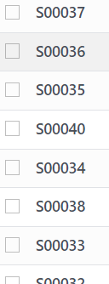

**New Addition:**

Cart-> Add label “Total shipment days” in cart total”  
 **Bugs:**

Products -> Add to Carts not working.

Carts -> Products Increment not working.

**Layout Issues:**Validations not working, layout is not as per standard

* **Product -> Create, Edit , Details, List (Search button not working, buttons should be visible with icons)**
* **Category -> Create, Edit, Details, List (Search button not working, , buttons should be visible with icons)**
* **Sub-Category -> Create, Edit, Details, List (Search button not working, , buttons should be visible with icons)**
* **Sale Order -> Details & List( buttons should be visible with icons)**

**Priority: Medium**

**Bugs:**  
  
**NavBar:**

Notifications

Chat (Optional) at the end of project.

User profile Dropdown not working

User Picture not visible with user name.

Search button not working, make it working or remove.

**Layout Issues:**Validations not working, layout is not as per standard

* **Dashboard -> Sidebar not working**

**New Form:**

* **Support -> Complain / Help Form**